

ASSET VERIFICATION AND RECORDING TOOL KIT


Plot 31, Bukoto Street
P.O Box 7657, Kampala, Uganda
+256 (0) 39 2000216/0772525235
email: cpa@cpa.ug

www.cpa.com

August to September 2026

VERIFICATION DETAILS

NAME OF THE REGION: | WESTERN REGION
SUB-REGION: | TOORO REGION
Name of Local Government | NTOROKO DISTRICT LOCAL GOVERNMENT
VERIFIER PARTICULARS
Full name | ZALWANGO MARIA, NASSEJJE NADIA, NABBOSSA SUMAYA
Contact/ email and Telephone | 0751977570,0754884004,0708098456
Supervisor/ Sub team leader
Name | DEPAUL MBONIGABA
Contact | 0788483159 depaulrukara@gmail.com
Date of submission

HEALTH CENTRES
INFORMANT INTERVIEW/DISCUSSION GUIDE (INCHARGE OR RESPONSIBLE PERSON)

Name of Health Centre: BWERAMULE H/C III

1a | Does the Facility have a record of all assets provided under UgIFT.  (Obtain a record and verify if it has the costs and numbers supplied | No
1b | If Not ask how many were supplied and when. | 70 assets on 15th/11/2024

2 | How does this facility Maintain (repair/service/replace) the assets provided under Ugift

The assets are still in store so far nothing is being damaged.

3 | Does the facility take regular record about functionality/ or breakdown of the assets provided? | No, the facility does not take regular functionality because all the assets are still in store not yet being used. All the buildings were in good condition.

4 | How has the UgIFT support helped in service delivery in the area, any issues, challenges and any recommendations for better program implementation. | Employment opportunities  The challenges were; the power house was on and off and also scarcity of water. The source of water that was constructed was faulty.  They recommend that if possible a borehole should be constructed for better services to be done.
11

PROCEED TO VERIFICATION AFTER THIS DISCUSSION

Health centre checklist

NAME OF LG NTOROKO DISTRICT LOCAL GOVERNMENT. NAME OF HEALTH FACILITY: BWERAMULE H/C III

Equipment/ Item | Department | Asset Number | Item  Description | Life in Months | Tag Number ( engrave no.) | Date Of Purchase | Date Placed In Service | Recoverable cost | Cost | Acc Dep Cost | Net Book Value | Ytd Deprn | Equipment status | Remarks
B.P. Machine, Digital | health |  |  |  |  |  |  |  |  |  |  |  |  | All the assets were still in store. They weren’t being used because they have not yet been paid for, they delivered them late yet the money had been swept back.  The power house was on and off.
B.P. Machine (Aneroid wall mounted)
Autoclave 20 Liters.,Duo Operated | health
Bowl, Kick | health
Bowl Stand | health |  | .
Counting chamber Neubauer- Improved
Cupboard Steel, Lockable | health
Drip Stand
ESR Stand | health |  | Boxed
Examination Couch | health
Examination light,LED | health
Glucometer | health
Haemoglobin Meter, Digital | health
Height Meter | health
Instrument Trolley | health
Microscope Binocular
Otoscope | health
Patient Screen
Patient Trolley
Refrigerator, Basic | Health
Stethoscope | health
Stop Watch | health
Stretcher | Health
Stove, Gas | health
Weighing Scale with Height Meter, Adult | health
Weighing Scale, Infant | health
Weighing Scale, Toddler | health
Wheel Chair | health
Audio Visual Equipment | Not verified
Medical Waste Bin | health
Wall Clock | health
Diagnostic Equipment Set for MCH | Not verified
Diagnostic Equipment Set for OPD | Not verified
Glassware Set, Laboratory, Basic | Not verified
Hollow Ware Set, Treatment | Not verified
Instrument Set, Dressing | Not verified
Instrument Set, Basic ENT | Not verified
Instrument Set, Suture | Not verified
Pulse Oximeter, Hand held | health
Bed, Adult Patient with Mattress | health
Bed, Pediatric Patient, With Mattress | health
Bedside Locker | health
Cupboard, Instrument | health
Delivery Bed, Hydraulic Manual | health
Oxygen Therapy Apparatus, Mininum 45L cylinder
Resuscitator Manual, Infant, with all Mask sizes | health
Resuscitator Manual, Adult, with all mask sizes | health
Suction Apparatus, (Electric) | health
Nebulizer, Ultrasonic | health
Oxygen Concentrator, Duo Flow
Bench
Disinfection Buckets | health
Baby Cot
Diagnostic Equipment Set for Ward
Hollow Ware Set, Ward | health
Instrument Set, Delivery
Instrument Set, Stitch Removing
MVA Kit | health
Stool, Laboratory
Penguin Sucker | health
Fetoscope, Dopplar
Bubble CPAP | health
Centrifuge (Electric) | health
Kangaroo Mother Care Chair | health
Radiant Infant Warmer | health
Haemoglobin Meter, Sahli
Delivery Bed
Examination light
Instrument set, ENT Basic for HCIII
Bag Valve mask (Ambu Bag), Neonatal | health
Incubator
Office Chair | health
Desk
Filing Cabinet | health
Non Residential Buildings
Residential Buildings | health

Compound Sign post Compound OPD
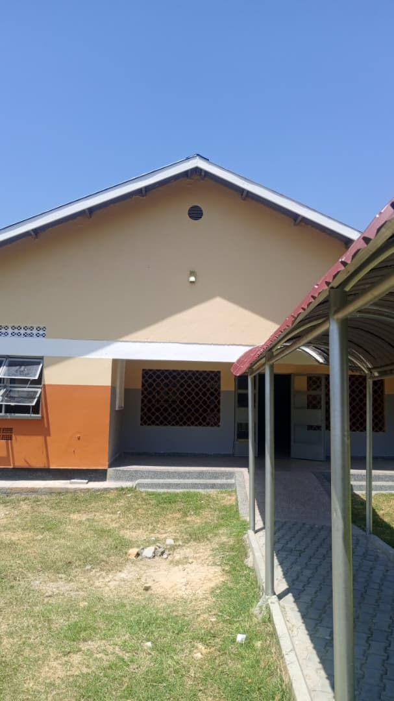
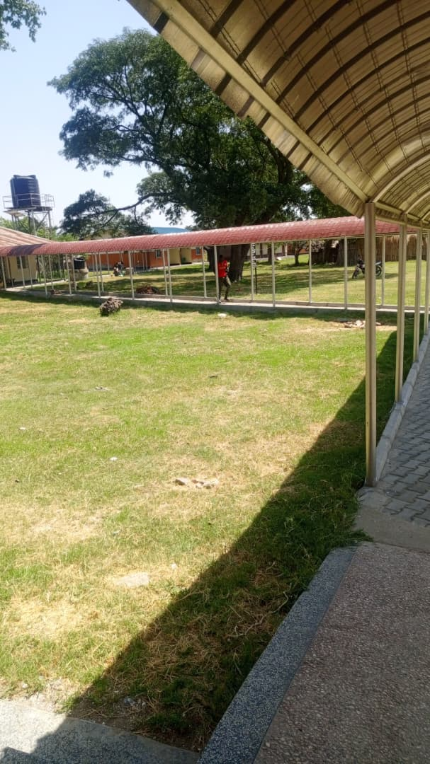
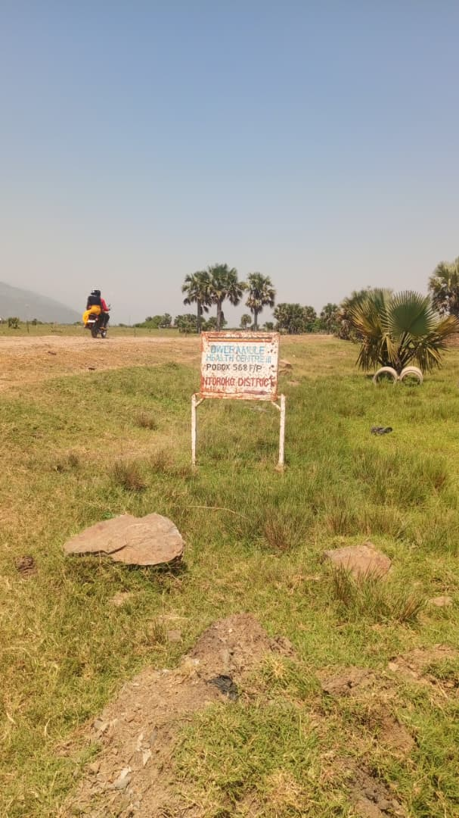
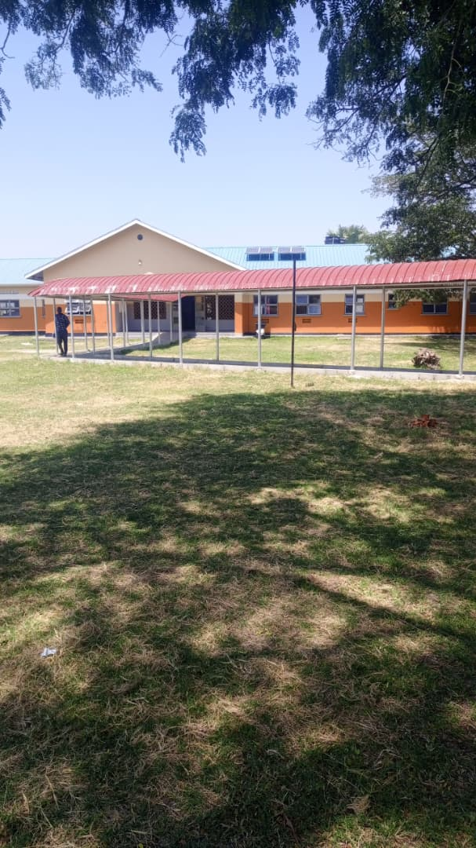
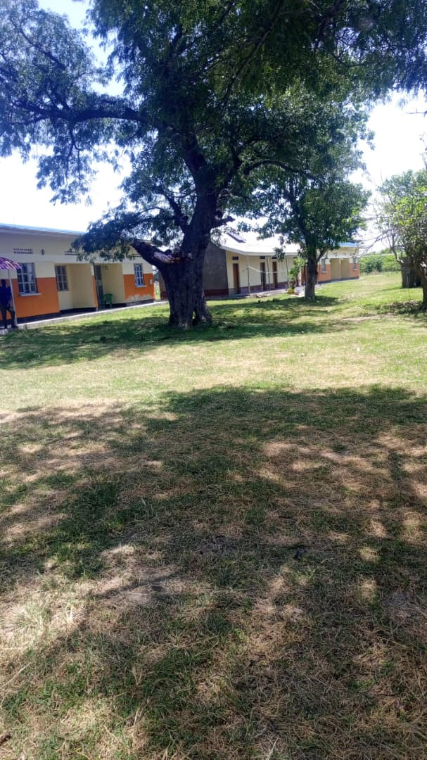

Staff quarters

